Lecture 1
Metalworking process classification
Definitions and classification. Metalworking processes as compared to other processes are classified as through-flow processes, in which virtual conservation of mass is retained as a result of the process. Although an extensive amount of plastic deformation occurs in the formation of a chip during metal cutting, this process are not considered as a metalworking process, but as a mass-reducing process.
Metalworking or metalforming is therefore defined here as an operation in which the change in shape of the processed workpiece or preform is not accompanied by an extensive amount of metal removal as the principal method of altering the shape. Some processes such as shearing, shaving, blanking, piercing, etc., may involve some metal cutting or chip formation. They nonetheless will be included here as metalforming, as the major part of the operation involves metalforming or else it is an important first step for a subsequent process such as making a blank for a deep-drawing operation.
A number of criteria or mechanisms are being used for the classification of metalworking processes. The main methods are follows:
1. Whether or not strainhardening occurs as in cold- or hotworking.
2. Type or state of stress involved at a certain point in the workpiece during metalworking.
3. Whether or not an appreciable change in thickness occurs during deformation as in bulk working or sheetmetal forming.
4. Size of the deformation zone, whether local or general.
5. Mode of deformation, whether steady or nonsteady state.
6. Rate of deformation, whether low, intermediate, or high.
7. Primary process such as rolling of plates and sheets; secondary forming processes such as deep-drawing, etc.
8. Continuous processes such as rolling and extrusion and batch processes such as closed die forging.
9. Whether or not chip formation is involved.
It is usual practice to classify the metalworking processes as follows:
1. According to the type of workpiece:
(a) Massive or bulk forming processes – the starting material is in the form of semifinished shapes, bars, billet, rod, slab etc.; the workpiece has a small surface to volume ratio; forming causes large changes in shape and cross section; the portion of the workpiece undergoing plastic deformation is generally much larger than the portion undergoing elastic deformation; therefore, elastic recovery after deformation is negligible.
(b) Sheetmetal processes – the starting material is rolled sheet; the workpiece has a large surface to volume ratio; forming causes large changes in shape but small changes in thickness; the elastic recovery is usually significant.
In both types of process, the surfaces of the deforming metal and the tools are in contact, and friction between them may have a major influence on material flow. Classification of bulk (massive) forming processes may be represented as following:
Forging: closed-die forging with and without flash, coining, upsetting, forward and backward extrusion forging, isothermal forging, nosing, open-die forging, rotary (orbital) forging, precision forging, metal powder forging, radial forging, swaging.
Rolling: sheet rolling, shape rolling, tube rolling, ring rolling, rotary tube piercing, gear rolling, roll forging, cross rolling, surface rolling, shear forming, tube reducing.
Extrusion: cold extrusion, nonlubricated hot extrusion, lubricated direct hot extrusion, hydrostatic extrusion.
Classification of sheet metal forming processes may be represented as following:
Bending and straight flanging: brake bending, roll bending.
Surface contouring of sheet: contour stretch forming (stretch forming), age forming, creep forming, die-quench forming, bulging, vacuum forming
Linear contouring: linear stretch forming (stretch forming), linear roll forming (roll forming), deep recessing and flanging, spinning (and roller flanging), deep drawing, rubber-pad forming, rubber-diaphragm hydroforming (fluid cell forming or fluid forming), shallow recessing, dimpling, drop hammer forming, electromagnetic forming, explosive forming, joggling
2. According to the effect of deformation and temperature on mechanical properties:
(a) Hot working – dynamic recovery occurs, no strainhardening, deformation temperature range is 0.7Tm < Tm < 0.8 Tm where Tm = incipient melting temperature.
(b) Warm working – some strainhardening and/or precipitation hardening may occur, deformation temperature range is 0.3 Tm < T < 0.5 Tm.
(c) Cold working – strainhardening occurs, deformation temperature range is <0.3 Tm.
3. According to the mode of deformation:
(a) steady state – continuous wire drawing, (b) non-steady state – die forging, and (c) mixed or transitory – extrusion.
4. According to the system of stresses imposed on the workpiece:
(a) compression – upsetting, drawing out, drop forging coining, pressing in closed die, extrusion, redusing, swaging, rolling, spinning conventional and power spinning;
b) tension – expanding, stretch forming, embossing;
(c) tension and compression – wire drawing, deep drawing, ironing;
(d) bending – at straight axis and at curved axis;
(e) torsion – setting;
(f) shear – shear spinning and shear pressing.
One of the main systems for the classification of the plastic-deformation processes is on the basis of a stress system. Subdivisions are made according to (1) the movement of the tool relative to the workpiece, (2) the tool geometry, (3) the workpiece geometry, and (4) the interrelation between the tool and workpiece geometry.
Quite a number of different definitions may be found in the literature or in use for the term “forging”. Forging is defined as a bulk, plastic deformation process of a metallic material, either hot or cold, to come predetermined shape primarily by compressive forces usually exerted by a hammer or press.
It is called a bulk deformation process because a significant change in the thickness of the workpiece usually occurs as compared to a sheetmetal process. When the term is used in a general sense, forging will include all bulk deformation processes of this class. When specific processes are meant, they will be referred to as hot, warm, or cold forging. When the forging of steel is mentioned without classification, hot forging will be meant.
Forging processes are classified as (1) typical or conventional production forging processes and (2) special or miscellaneous forging processes. The first category will include all hot-working processes, which are done above the recrystallization temperature and for carbon and alloy steels, in the austenite range, and by use of forging hammers, presses, and/or upset forging machines. The second category will include all cold-working operations such as warm and cold forging, and forging done by the less common types of forging equipment such as roll forging, ring and wheel forging, rotary forging and swaging, shear forming, typical extrusion processes, etc.
Forging in the conventional sense may be classified as (1) open-die (flat-tool or smith forging), and (2) closed-die or impression-die forging, sometimes called drop forging; however, both of these categories are subject to some confusion. Open-die forging is the term applied to all forging operations, in which there is no lateral constraint except for friction and consequently no three-dimensional confinement. Closed-die forging is the term applied to all forging operations involving three-dimensional control. Sometimes the distinction between open-and closed-die forging is not too clear, such as, for example, in swaging and edging operations, in which a considerable amount of lateral confinement may occur. In these cases, however, the nature of the forging operations and the equipment used will definitely place them in one category or the other.
Open-die or smith forging is done with a hand hammer, a power hammer or a power press by use of tools or dies that are flat or nearly flat, in which the manipulation of the workpiece is done by hand or by a mechanical manipulator.
Closed-die forging is used (1) when the desired shape is complicated, (2) when the quantity of forgings required is large so the time and cost of making closed dies may be justified, (4) where the forging isn’t so large as in open-die forging.
All types of bulk forging operations may be classified as follows:
Bending. (1) A preliminary forging operation to change the axis of the workpiece and to give the piece approximately the correct shape for subsequent forming. (2) The straining of flat sheet or strip metal, by moving it around a straight axis lying in the neutral plane. Metal flow takes place within the plastic range of the metal, so that the bent part retains permanent set after removal of the applied stress.
Cogging. The systematic reducing forging operation for working the ingot into a billet by the use of a forging hammer or a forging press.
Coining. (1) A closed-die squeezing operation in which all or some portion of the surfaces of a workpiece are confined or restrained, to obtain closer tolerances or smoother surfaces or to eliminate draft or resulting in a well-defined imprint of the die on the work. (2) A restriking operation used to sharpen or change an existing radius or profile. Coining can be done while forgings are hot or cold and is usually performed on surfaces parallel to the parting line of the forging.
Drawing out. A forging operation in which the cross section of stock of any shape is reduced and the stock lengthened between flat or simple contour dies. See also cogging.
Edging. (1) In sheet metal forming, reducing the flange radius by retracting the forming punch a small amount after the stroke but before release of the pressure. (2) In rolling, the working of metal in which the axis of the roll is parallel to the thickness dimension. Also called edge rolling. (3) The forging operation of working a bar between contoured dies while turning it 90° between blows to produce a varying rectangular cross section. This operation serves for gathering and rearranging the material so that it is properly distributed to fill the cavities
Extrusion. The conversion of an ingot or billet into lengths of uniform cross section by forcing metal to flow plastically through a die orifice. In forward (direct) extrusion, the die and ram are at opposite ends of the extrusion stock, and the product and ram travel in the same direction (in the same direction in which energy is being applied). Also, there is relative motion between the extrusion stock and the die. In backward (indirect) extrusion, the die is at the ram end of the stock and the product travels in the direction opposite that of the ram, either around the ram (as in the impact extrusion of cylinders such as cases for dry cell batteries) or up through the center of a hollow ram.
Heading. An upsetting process involving only a part of the billet and used to form heads on the ends of rods or wire, as in bolt or rivet making or process used to form parts that usually contain portions that are greater in cross-sectional area than the original wire, rod, or bar. Heading may be done by heating only a part of the billet (the end or the middle) or by restricting deformation of a section of the billet by means of a ring-shaped tool.
Hydrostatic extrusion. A method of extruding a billet through a die by pressurized fluid instead of the ram used in conventional extrusion. The billet is smaller in diameter than the chamber. Unlike in conventional extrusion, there is no friction to overcome along the container walls.
Ironing. (1) A press operation used to obtain a more exact alignment of the various parts of a forging, or to obtain a better surface condition. (2) An operation to increase the length of a tube by reduction of wall thickness and outside diameter. See also Coining, Swaging.
Isothermal forging (hot-die forging). A hot-forging process in which a constant and uniform temperature is maintained in the workpiece during forging by heating the dies to the same temperature as the workpiece.
Powder forging. The plastic deformation of a powder metallurgy compact or preform into a fully dense finished shape by using compressive force; usually done hot and within closed dies.
Precision forging. A forging produced to closer tolerances than normally considered standard by the industry.
Radial forging (rotary swaging). A process using two or more moving anvils or dies for producing shafts with constant or varying diameters along their length or tubes with internal or external variations in diameter. Often incorrectly referred to as rotary forging.
Reducing. Forging operation when a bar or a rod is pushed through the matrix for the purpose of reduction of a cross section.
Rolling. (1) The forging operation of working a bar between contoured dies while turning it between blows to produce a varying circular cross section. (2) The reduction of the cross-sectional area of metal stock, or the general shaping of metal products, through the use of rotating rolls.
Rotary forging. A process in which the workpiece is pressed between a flat anvil and a swiveling (rocking) die with a conical working face; the upper die moves along an orbital path and the platens move toward each other during forging; the part is formed incrementally. Also called orbital forging. Compare with radial forging.
Shear spinning (power spinning, flow turning, hydrospinning or spin forging). Process of plastic working of metal producing parts to a predetermined geometrical shape by displacing metal in advance of a roller that is fed along a mandrel machined to the desired inside diameter of the part. Usually, hydraulic pressure is used to force the roller against the part and for clamping the blank to the tailstock. In this process, the metal is displaced in the direction of the feed of the roller along the length of the mandrel.
Spinning. The forming of a seamless hollow metal part by forcing a rotating blank to conform to a shaped mandrel that rotates concentrically with the blank. In the typical application, a flat-rolled metal blank is forced against the mandrel by a blunt, rounded tool; however, other stock (notably, welded or seamless tubing) can be formed. A roller is sometimes used as the working end of the tool.
Swaging. A radial compression operation to reduce the size of the forging stock due to compression between longitudinal, semicircular or semicontoured dies; to shape metal by causing it to flow in a swage by pressing, rolling, or hammering.
Upsetting. The compression operation usually parallel to the longitudinal or cylindrical axis of the workpiece so that the cross-sectional area of a portion or all of the stock is increased.

COMPRESSION | Drawing out | 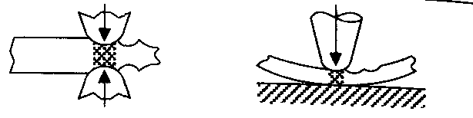
COMPRESSION | Drop forging coining | 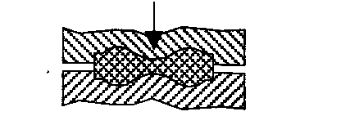
COMPRESSION | Extrusion | 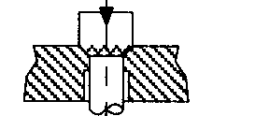
COMPRESSION | Reducing
COMPRESSION | Swaging | 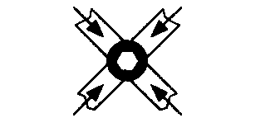
COMPRESSION | Rolling | 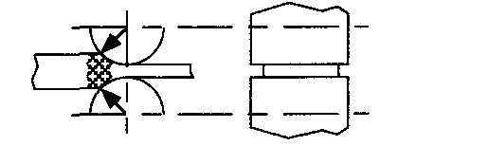
COMPRESSION | Reducer Rolling | 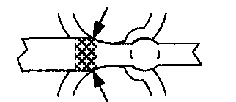
COMPRESSION | Conventional spinning | 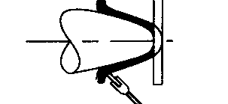
COMPRESSION | Power spinning | 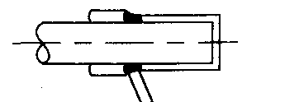
TENSION | Expanding | 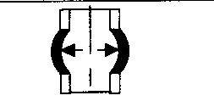
TENSION | Stretch forming | 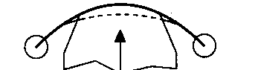
TENSION | Embossing | 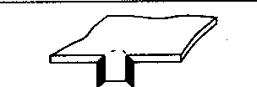
TORSION AND COMPRESSION | Wire drawing
TORSION AND COMPRESSION | Deep drawing with blank-holder  Without blank holder | 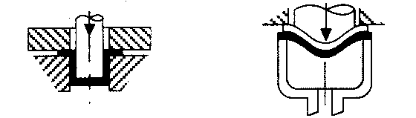  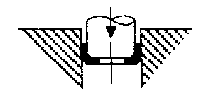
TORSION AND COMPRESSION | Ironing | 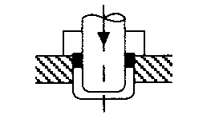
BENDING | Bending at straight axis | 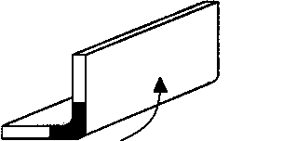
BENDING | Bending at curved axis | 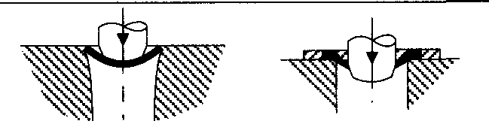
SHEAR | Shear spinning | 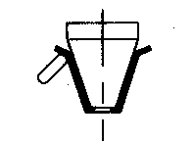
SHEAR | Shear pressing | 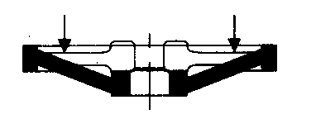
TORSION | Setting | 