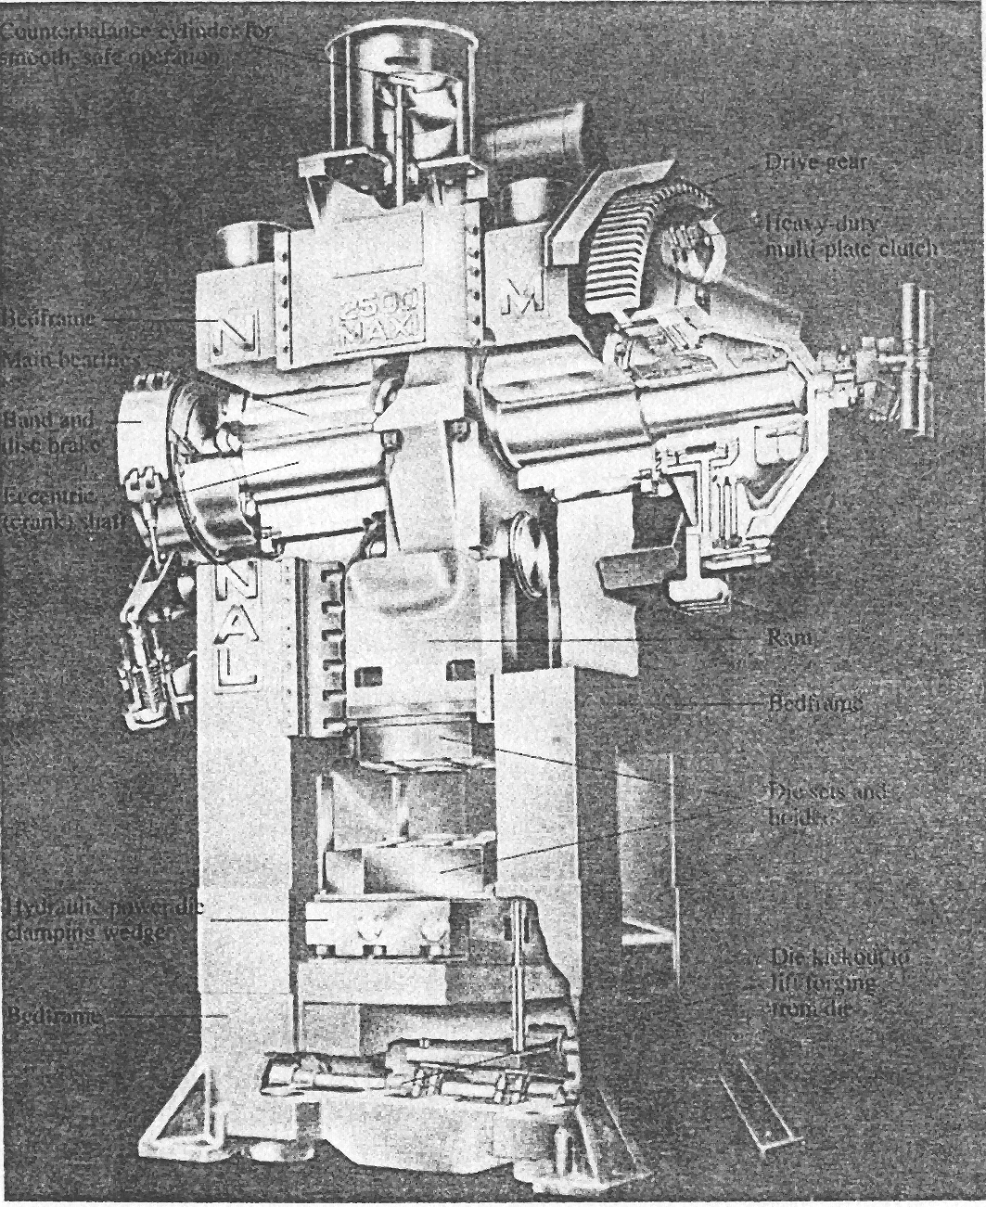
Drive gear
Multi-plate clutch
Ram
Bed frame
Die sets and helds
Die kickout
Bed frame
Hydraulic power die clamping wedger
Eccentric (crank) shaft
Band and disc brake
bedframe
cylinder
Main bearings
Fig. 8.1. Mechanical press

Fig.11.4 Crank press: 1- electric motor; 2- V-belt transmission; 3- fly-weel; 4- countershaft; 5- gearing;
6- crank shaft; 7- connecting-rod; 8- friction coupling; 9-bed plate; 10-ram; 11- band brake
1
2
4
8
11
5
3
6
10
7
9

Classification of the forging equipment
Many process parameters affect the selection of forging equipment. They are: required load and energy, the flow stress, strain rate, temperature, geometry of forging, friction.
Metalworking processes differ from other types of manufacturing processes by very high working loads (specific resistance to deformation), when power inputs have short-time, transient nature. So most of forging equipments actually are the “accumulator of the power” and some types of accumulators are provided in their design to ensure peak release of the stored energy. Different kinds of combination of accumulators and transferring mechanisms form variety of the forging machines.
The main principle for classification of the forging equipment may be type of changing of the velocity of the slider or ram during working stroke or its displacement during deformation of the work piece. According this principle all types of the forging equipment may be subdivided into 4 groups: hammers, hydraulic presses, crank presses and rotary compression-type machines.
Another classification takes into account not only type of changing of the velocity of the slider or ram during working stroke but principle of operation and nature of action on the workpiece.
These machines can also be classified into three types relating to the type of the restriction: load-restricted machines (hydraulic presses), stroke-restricted machines (crank and eccentric, or mechanical, presses), and energy-restricted machines (hammers and screw presses).
The significant characteristics of pressing-type machines comprise all machine design and performance data that are pertinent to the economical use of the machine. These characteristics include:
Characteristics for load and energy: Available load, available energy, and efficiency factor (which equals the energy available for workpiece deformation/energy supplied to the machine)
Time-related characteristics: Number of strokes per minute, contact time under pressure, and velocity under pressure.
Characteristics for accuracy: For example, deflection of the ram and frame, particularly under off-center loading, and press stiffness.
Presses
Presses – forging machines of quasistatic action on workpiece, where the squeezing action of the ram is fulfilled during its movement and loads of deformation are received by closed carrying frame. Pressing-type machines are the most widely used and are applied to both bulk and sheet forming processes. Depending on design of the basic actuating mechanism 3 groups of the presses may be classified:
– crank, eccentric and cam (or mechanical) presses (with kinematically defined variation of the ram velocity);
– hydraulic presses;
– screw presses (with arbitrary variation of the ram velocity).
The main parameter of the presses is available load and energy. The flywheels are used as accumulators of energy in screw and crank presses, hydroaccumulators in hydraulic presses.
Mechanical presses. Mechanical presses are basically either the crank or eccentric type with speeds that vary from a maximum at the center of the stroke to zero at the bottom of the stroke. These presses are thus stroke limited. The energy in a mechanical press is generated by a large flywheel powered by an electric motor. A clutch engages the flywheel to an eccentric shaft. A connecting rod translates the rotary motion to a reciprocating linear motion. In a knuckle-joint mechanical press very high forces can be applied because of the linkage design.
Eccentric press. A mechanical press in which an eccentric, instead of a crankshaft, is used to move the slide. The motion of the tool is driven by the rotation of a crank. This is similar to a crank press, but the rod can be positioned along the radius of the crank. The velocity of tool has a sinusoidal variation in time.
Cam press. A mechanical press in which one or more of the slides are operated by cams; usually a double-action press in which the blankholder slide is operated by cams through which the dwell is obtained.
Crank press. A mechanical press whose slides (motion of the tool) are actuated by a crankshaft (by the rotation of a crank). The velocity of tool has a sinusoidal variation in time.
Some of the advantages cited for mechanical forging presses over drop hammers are (1) higher production rates are possible, (2) dies are less massive because of less impact, and (3) less operator skill is required.
Some disadvantages of mechanical presses over hammers are (1) higher initial cost, (2) less adapted to preforming operations such as fullering and rolling, (3) less suitable for unsymmetrical parts.
The force available in a mechanical press depends on the stroke position and becomes extremely high at the bottom dead center. Thus proper setup is essential to avoid breaking the dies or equipment components. Press capacities generally range from 2.7 MN (300 tons) to 107 MN (12,000 tons). Mechanical presses have high production rates, are easier to automate, and require less operator skill than other types of forging machines.
Hydraulic presses. Hydraulic presses operate at constant speeds and are load limited, or load restricted. In other words, a press stops if the load required exceeds its capacity. Large amounts of energy can be transmitted to the workpiece by a constant load throughout the stroke, the speed of which can be controlled. Because hydraulic-press forging takes longer than other types of forging machines, the workpiece may cool rapidly unless heated dies are used. Compared to mechanical presses, hydraulic presses are slower, involve higher initial cost, but require less maintenance.
A hydraulic press typically consists of a frame with two or four columns, pistons, cylinder, rams, and hydraulic pumps driven by electric motors. The ram speed can be varied during the stroke. Press capacities range up to 125 MN (14,000 tons) for open-die forging and 670 MN (75,000 tons) for closed-die forging. The main landing-gear support beam for the Boeing 747 aircraft is forged in a 450-MN (50,000-ton) hydraulic press. This part is made of titanium alloy and weighs approximately 1350 kg.
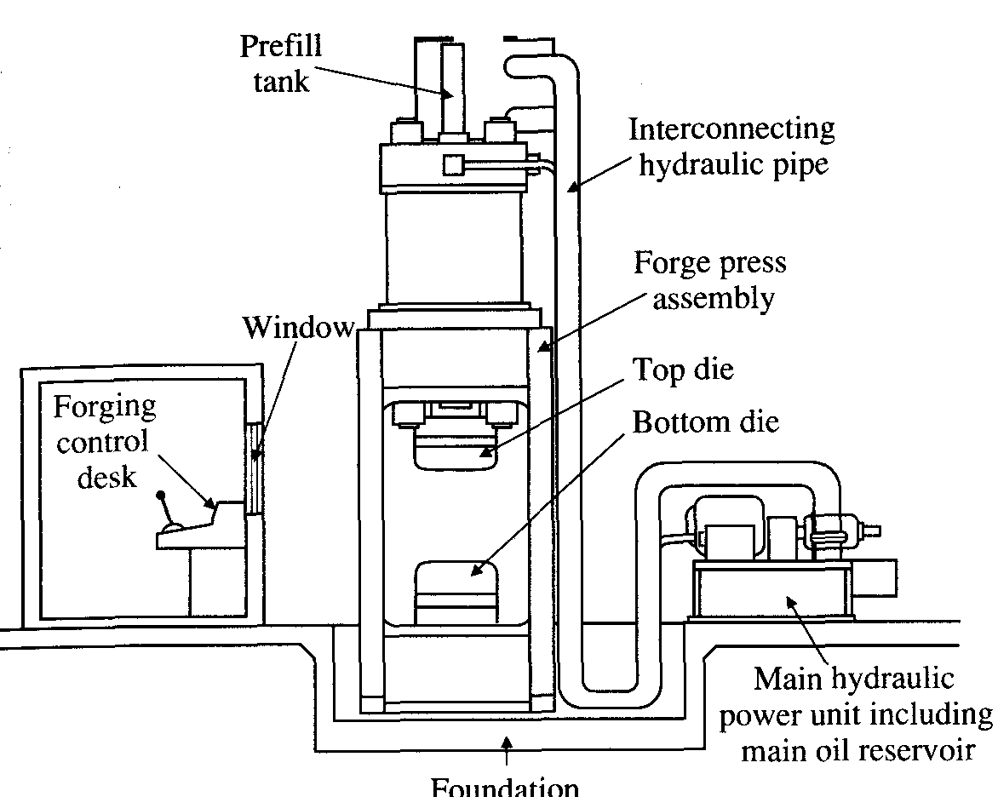
Hydraulic closed-die forging presses. Hydraulic presses used in closed-die forging are similar in principle to those used for open-die forging but they are usually smaller. The basic difference between a hydraulic forging press and other forging equipment is that the pressure is applied by a squeezing action rather than by impact. They are of two basic types: (1) direct drive hydraulic presses, which operate with hydraulic fluid (oil or water) pressurized directly by high-pressure pumps, and (2) accumulator-drive hydropneumatic presses, which usually operate with a water-oil emulsion as the working fluid and which use accumulators loaded with nitrogen, steam, or air to pressurize the working fluid. Many hydraulic presses are equipped with control circuits providing a rapid advance, a slow working stroke, and a dwell period, if desired.
Fig. 8.3. Hydraulic press with a remote hydraulic power unit
Foundation
Some advantages of hydraulic presses are (1) pressure can be changed as desired at any point of the stroke, (2) rates of deformation can be controlled, (3) split dies can be used to forge complex parts, and (4) they have better die life and less die maintenance because of the gentle squeezing action. Some disadvantages are (1) high initial cost, (2) slower acting than mechanical presses, and (3) longer contact of the heated workpiece with the die, resulting in greater heat transfer and reduced die life.
Screw presses. Screw presses derive their energy from a flywheel; hence they are energy limited. The screw press uses a friction, gear, electric, or hydraulic drive to accelerate a horizontal flywheel connected to a vertical screw assembly to convert the angular kinetic energy to linear energy of the slide or ram. Stored to the end of the working stroke energy and nominal load are the main characteristics. The forging load is transmitted through a vertical screw. The ram comes to a stop when the flywheel energy is dissipated. If the dies do not close at the end of the cycle, the operation is repeated until the forging is completed. Capacities range from 1.4 MN to 280 MN (160 tons to 31,500 tons). Screw presses are used for various open-die and closed-die forging operations, and are particularly suitable for small production quantities and precision parts, such as turbine blades.
Fig. 11.5 Friction (fly)-press: 1- electric motor; 2- belt transmission; 3- friction plate; 4-shaft; 5-flywheel; 6- screw; 7- slider; 8-bad; 9-operation lever

Hammers
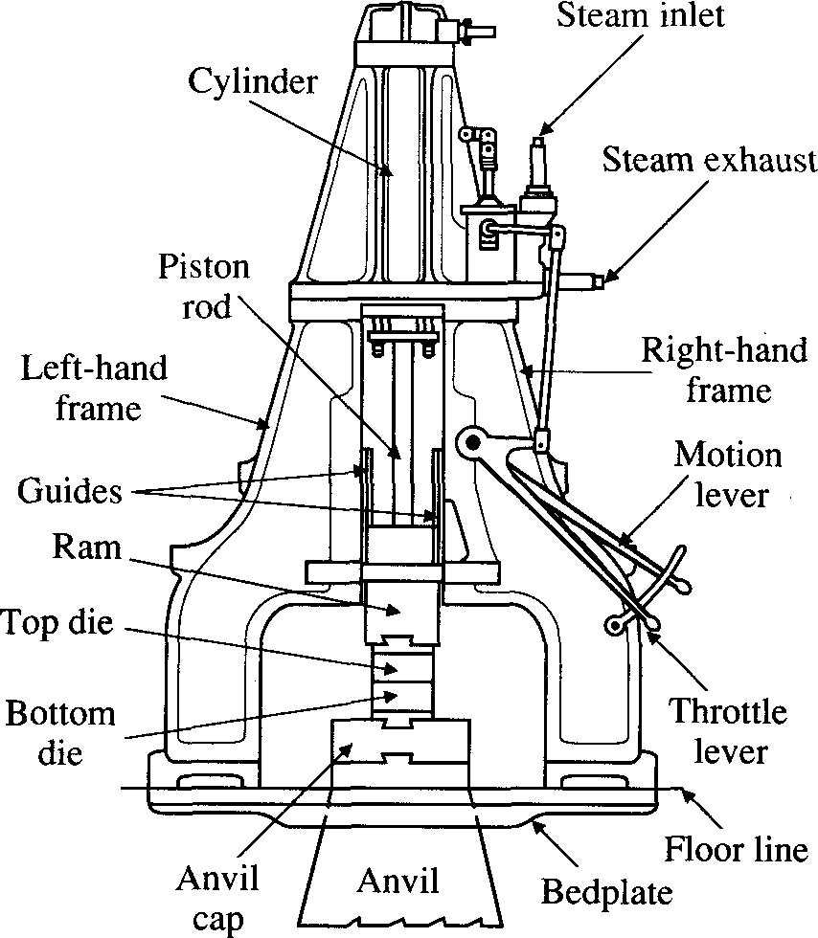
Hammers derive their energy from the potential energy of the ram, which is converted to kinetic energy; thus they are energy limited. Unlike hydraulic presses, they operate at high speeds, and the low forming times minimize cooling of the hot forging. Low cooling rates allow the forging of complex shapes, particularly those with thin and deep recesses. To complete the forging, several successive blows are usually made in the same die. Hammers are the most versatile and least expensive type of forging equipment. The stored in the ram kinetic energy is the main characteristics of hammers. The moving mass is the accumulator of the energy in the hammer.
Fig. 8.2. Double-frame, steam-driven power hammer
Hammers are characterized by additional features:
- In the beginning of the working stroke energy of the moving mass with die is greater than work of deformation.
- Alteration of the velocity of the moving mass during the working stroke is arbitrarily from maximum to zero.
- The frame of the hammer takes force which is less than load of deformation.
Hammers are classified according to following characteristic feature: function, type and repetition factor of the driving mechanism and design.
On function there three type of the hammers: open die forging, closed die forging and sheet metal forging hammers.
On type of driving mechanism:
- steam-air hammers;
- compressed air hammers;
- electric hammers;
- electro-mechanical hammers;
- gas-hydraulic hammers;
- hydraulic hammers;
- gas hammer;
- explosive hammer.
On repetition factor there are single-acting and double-acting hammers.
On design there are single-frame and double-frame hammers, arched and bridge hammers.
Gravity drop hammers. In the gravity drop hammer (hence the term drop forging) the energy is derived from the free-falling ram. The available energy of the hammer is the product of the ram's weight and the height of its drop. Ram weights range from 180 kg to 4500 kg (400 Ib to 10,000 Ib), with energy capacities ranging up to 120 kJ (90,000 ft-lb).
Air-lift gravity drop hammers. In the air-lift gravity drop hammer, the ram assembly is raised by air or steam but drops by gravity when released. The ram is held in the raised position by a piston-rod clamp. Cycling is continued while the treadle is kept depressed. The length of stroke can be controlled.
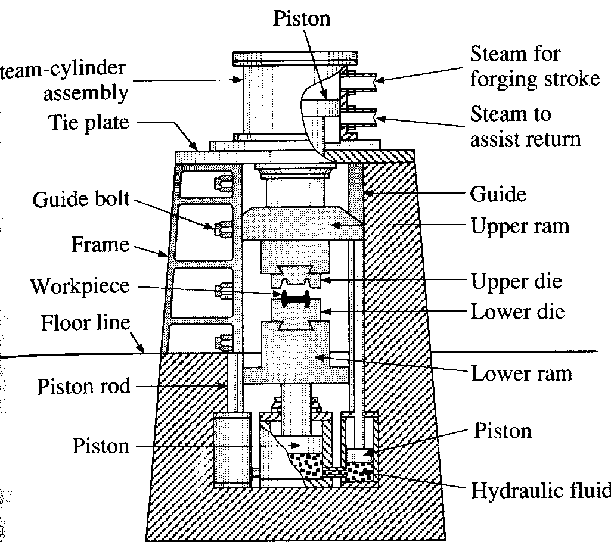
Power drop hammers. In the power drop hammer the force of the dropping ram assembly is supplemented by a pressure of steam or air acting on the piston in the cylinder. Power drop hammers are rated by the weight of the striking mass. In the power drop hammer the ram's downstroke is accelerated by steam, air, or hydraulic pressure at about 700 kPa (100psi). Ram weights range from 225 kg to as much as 22,500 kg (500 Ib to 50,000 Ib), with energy capacities ranging up to 1150 kJ (850,000 ft-lb).
Fig. 8.5. Components of a vertical counterblow hammer with a steam-hydraulic actuating system

Steam cylinder
assembly
Counterblow hammers. The striking force develops from the movement of two rams from opposite directions and meeting at the midpoint. The vibration of impact is reduced and approximately full energy of each blow is delivered to the workpiece without loss to an anvil. Vertical hammers are rated in m-kg. A counterblow hammer has two rams that simultaneously approach each other by air or steam pistons, either horizontally or vertically, to forge the part. As in open-die forging operations, the part may be rotated between blows for proper shaping of the workpiece during forging. Counterblow hammers operate at high speeds and transmit less vibration to their bases. Capacities ranee up to 1200 kl (900,000 ft-lb).
High-energy-rate machines. In a high-energy-rate machines the ram is accelerated by inert gas at high pressure, and the part is forged in one blow at very high speeds. Although there are several types for these machines, various problems associated with their operation and maintenance, die breakage, and safety considerations limit their actual use in forging plants.
Board drop hammers. In this hammers the ram is lifted by one or more boards, which is keyed to it and which passes between two friction rolls at the top of the hammer. As the board is rolled upward, it is tripped mechanically allowing the ram to drop from the predetermined desired height, which cannot be altered without stopping the machine. A single stroke is obtained by depressing the treadle once and releasing it. Successive strokes are obtained by keeping the treadle depressed. The size of the hammer is rated on the basis of the weight of the ram assembly excluding the upper die. Board hammers have falling weights, or rated sizes, of 100 to 10,000 Ib.
Rotary impact (swaging) machines. In this machines the ram with tool is rotated with continuous movement of contact zone with workpiece. The main characteristics of the swaging machines are nominal load or nominal torque. Such machines may have no accumulator of energy due to continuous action or have flywheels as accumulator.
Fig.11.3
Board drop hammers: 1-anvil; 2- dies; 3-ram; 4-board; 5,8- brake blocks; 6,7- power-driven rollers; 9- lever for pressing roll 7 to board; 10- operating levers; 11- operating treadle.
11
Impulse machine. In this machines energy resources (explosive, gas, gunpowder) are used as accumulators of energy.

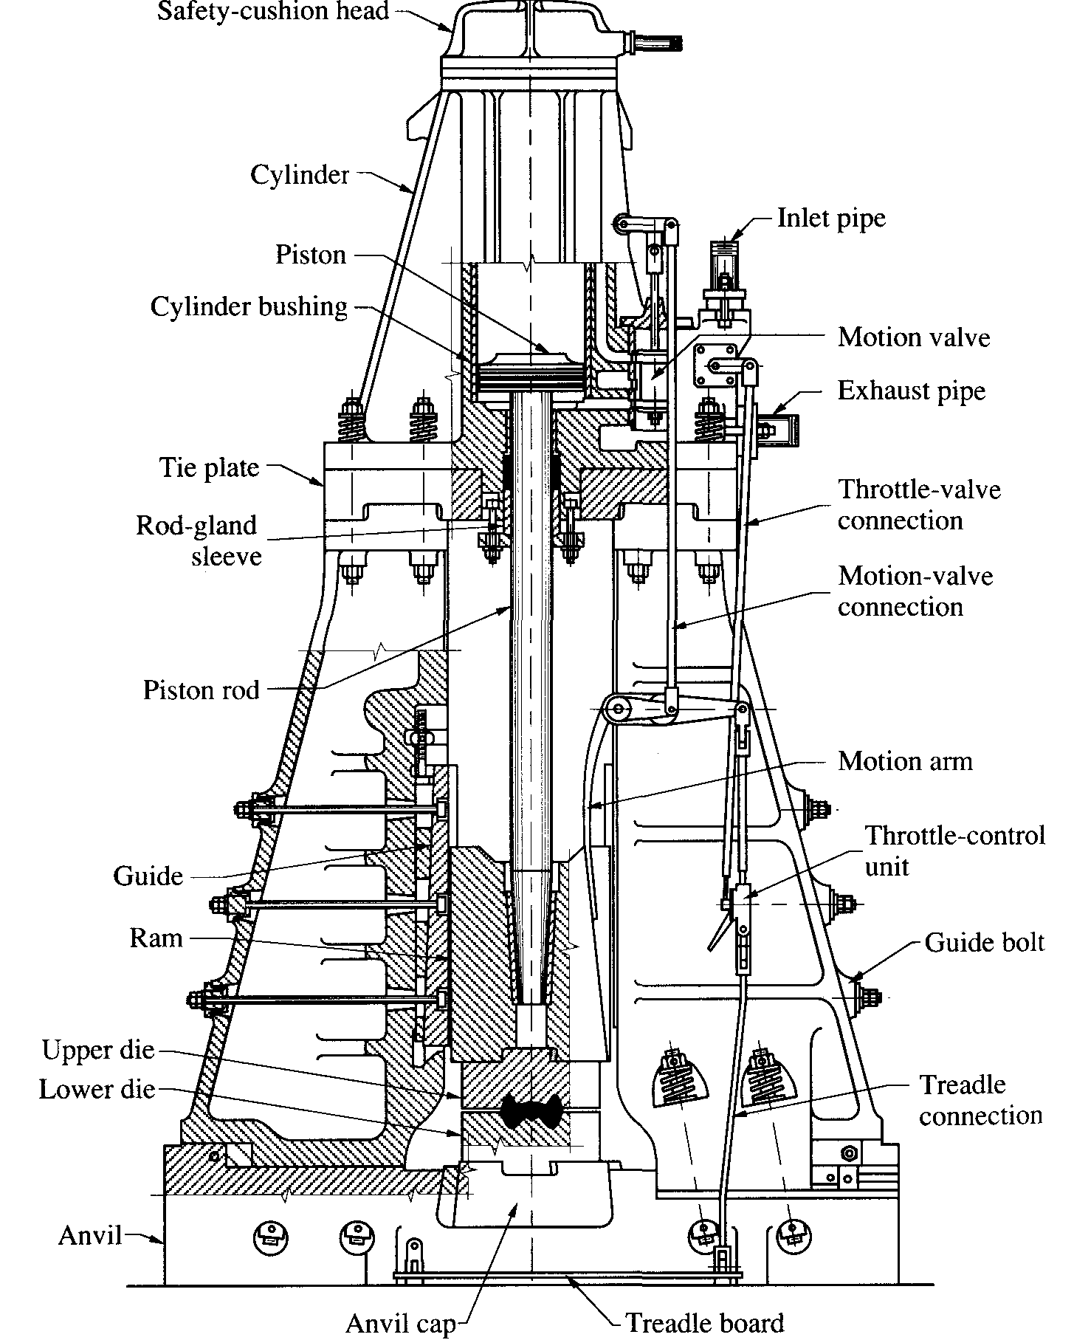
Fig. 8.4. Principal components of a power drop hammer with foot control to regulate the force of the blow

